|  |  |
| --- | --- |
| Student ID | IT22361004 |
| Batch | 1.2 |
| Marks |  |
| 1. Code Quality and Organization (2 Points) |  |
| 1. Functionality (4 Points) |  |
| 1. Creativity and User Interface Design (2 Points) |  |
| 1. Performance and Stability (2 Point) |  |
| Total: 10 Marks |  |
| Evaluator |  |

**Description:**

"Fishy Catch Frenzy" is a delightful game where players assist a hungry cat in catching falling fish. Inspired by the playful antics of a beloved feline friend who has passed away, this game serves as a heartfelt tribute to their memory. As fish drop from above, players must swiftly maneuver the cat to snag as many as possible before they hit the ground. With simple yet addictive gameplay, "Fishy Catch Frenzy" offers hours of fun for players of all ages, celebrating the special bond between cats and their owners.



**Instructions:**

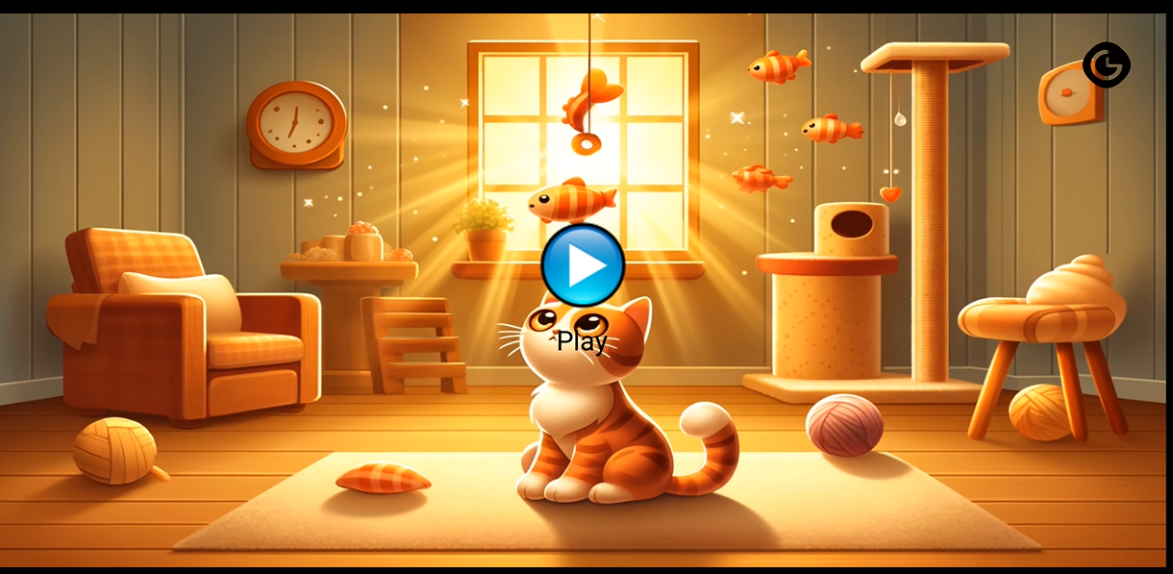



Press Play Button to begin the gameplay

Press on this button to View the match history

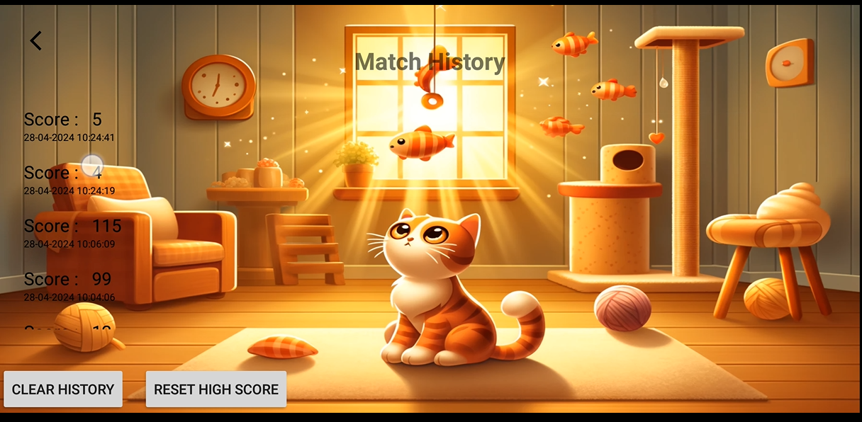

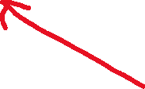

Press this button to Clear the match history Press this button to Reset the High Score

This Section Displays the current score and the highest score This indicates the life

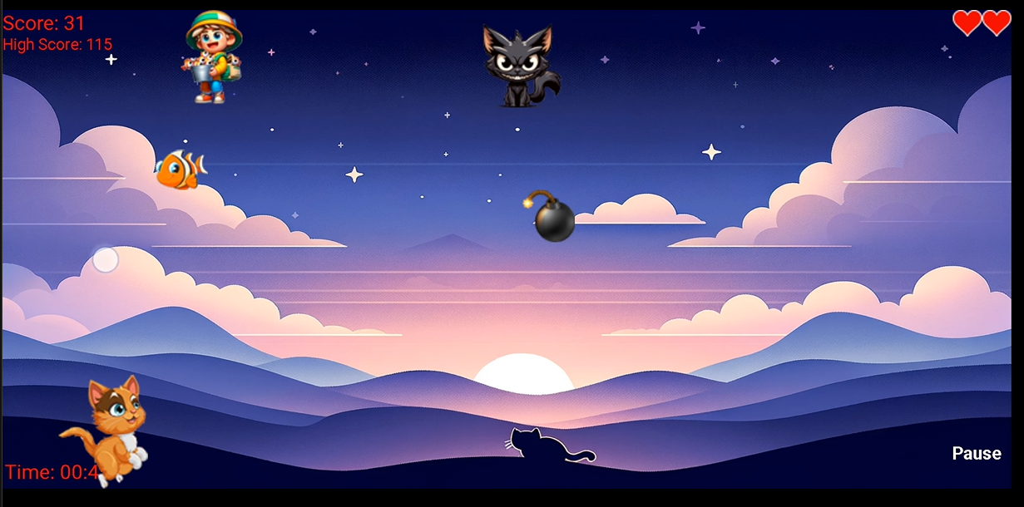



Press This to pause the game or resume the game

Human which Throws Fish Evil Cat

Catching this increases Life by 1

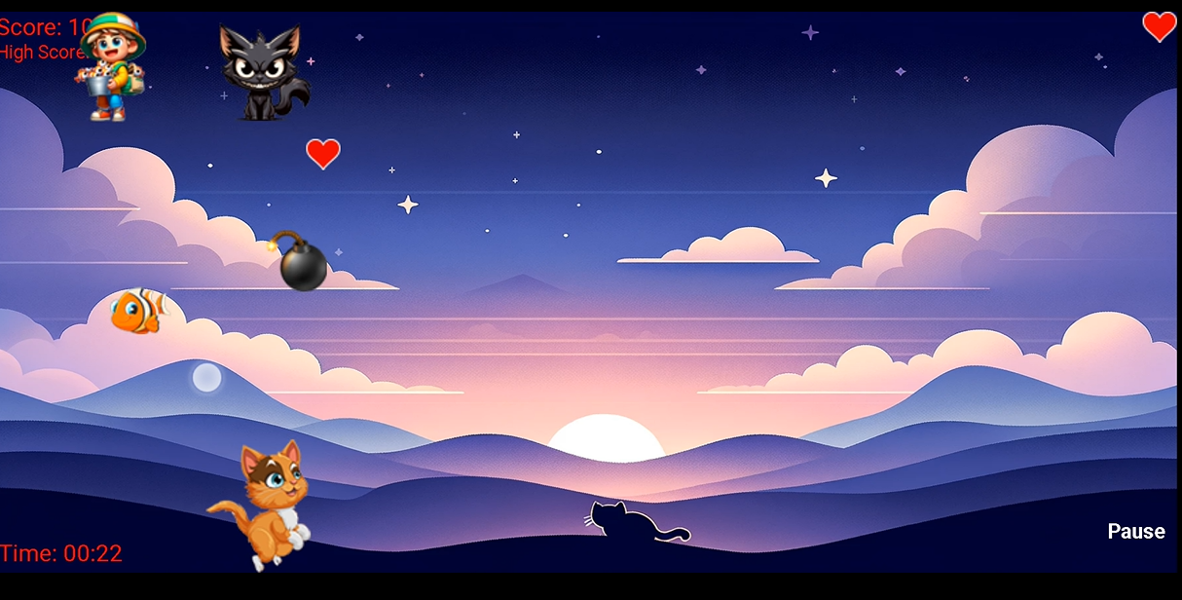

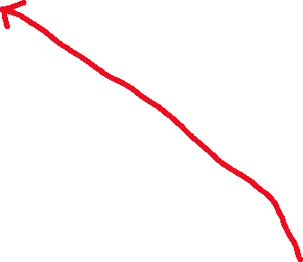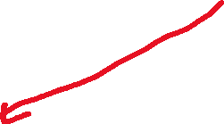

Fish(if this object goes out of the screen life deducts by 1

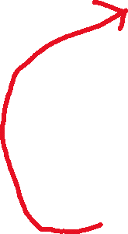

If the Cat gets gets hit by bomb life will be deducted by 2

Cat can Move horizontally to Catch Fishes

To Restart End game



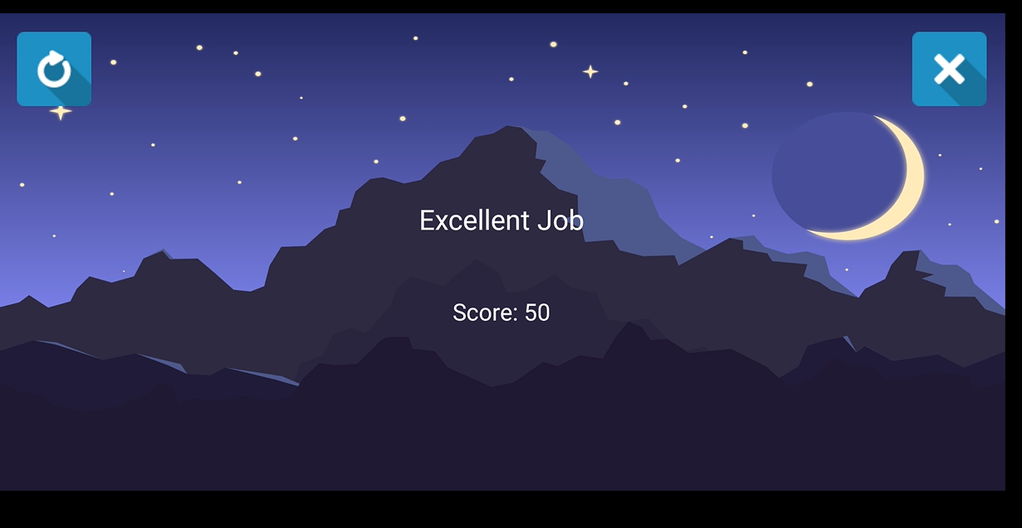

**Screenshots:**

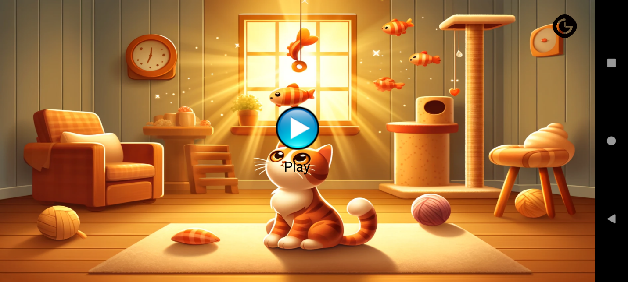

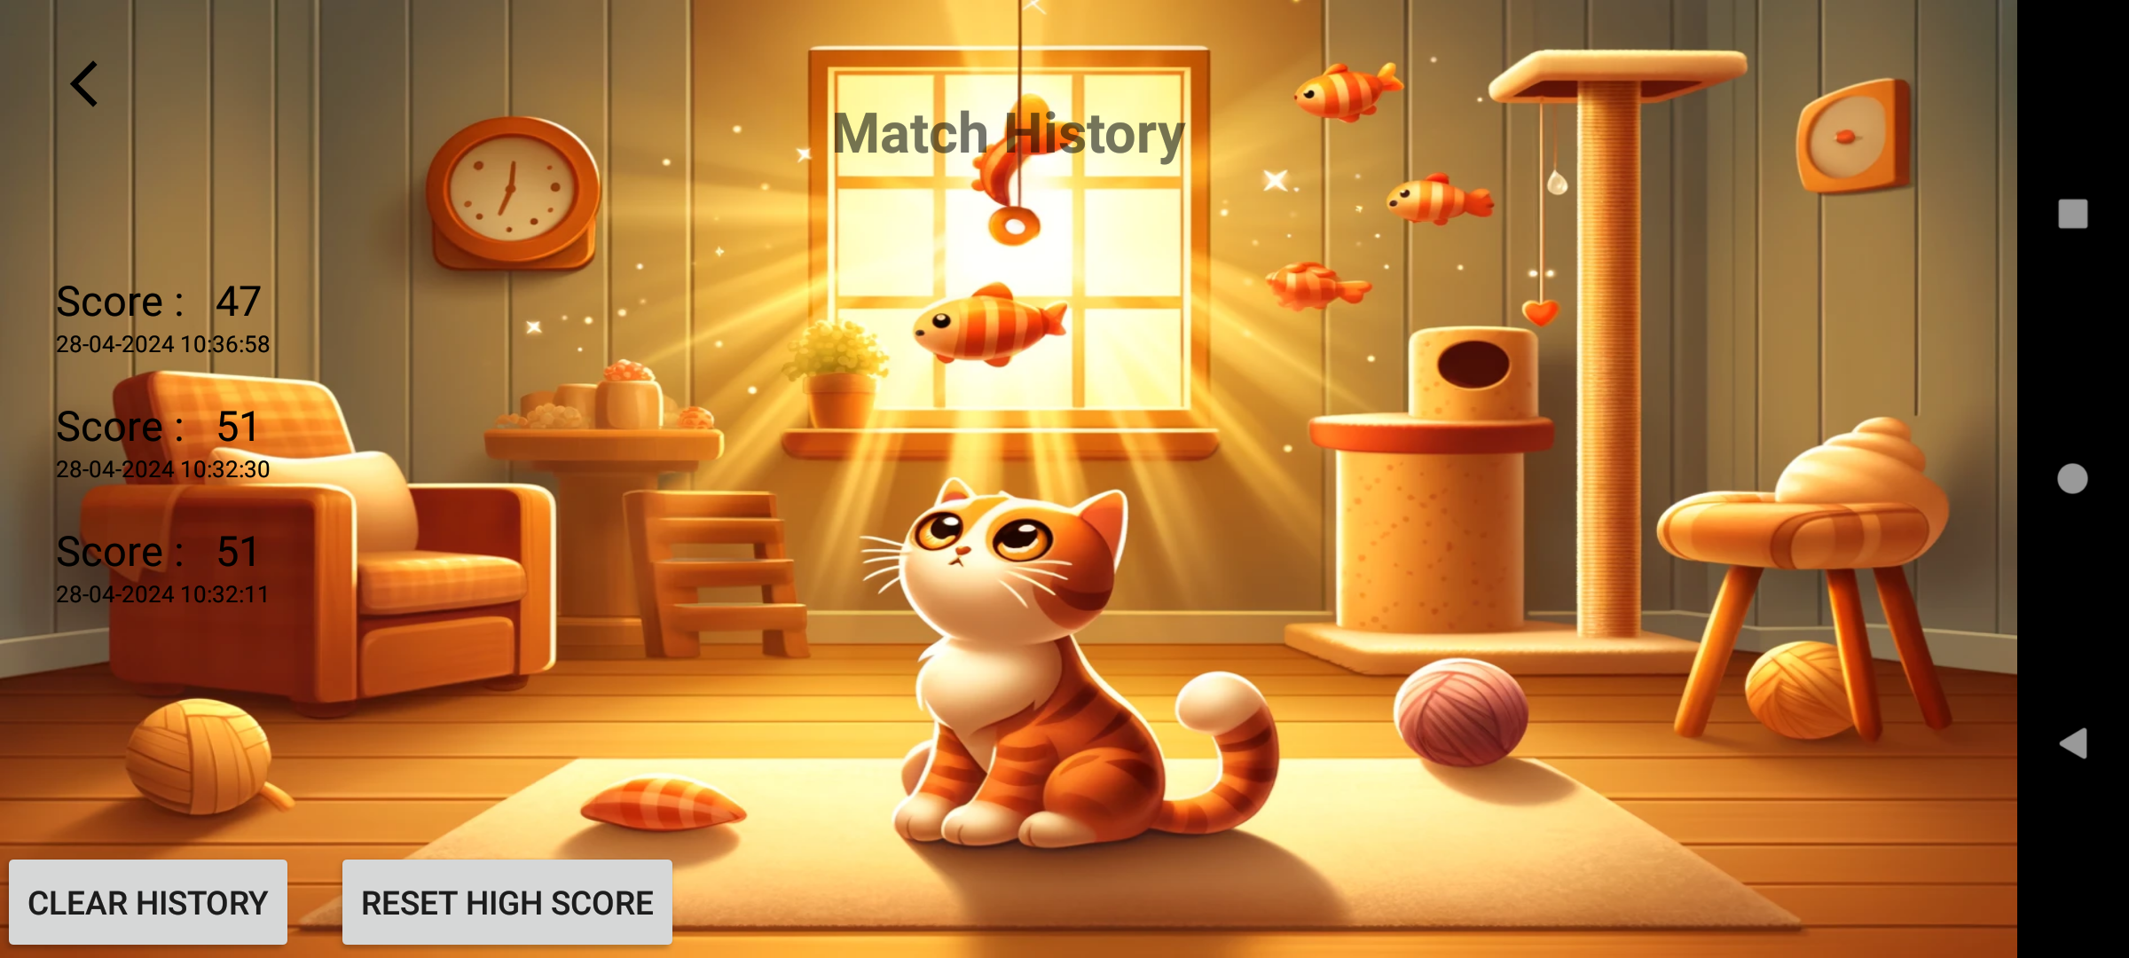

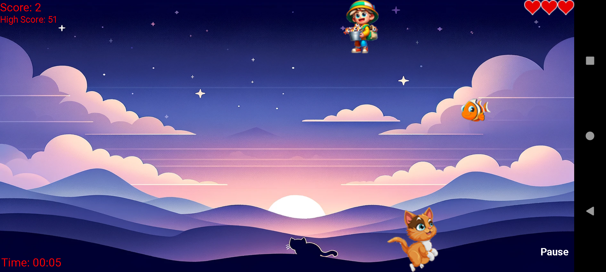

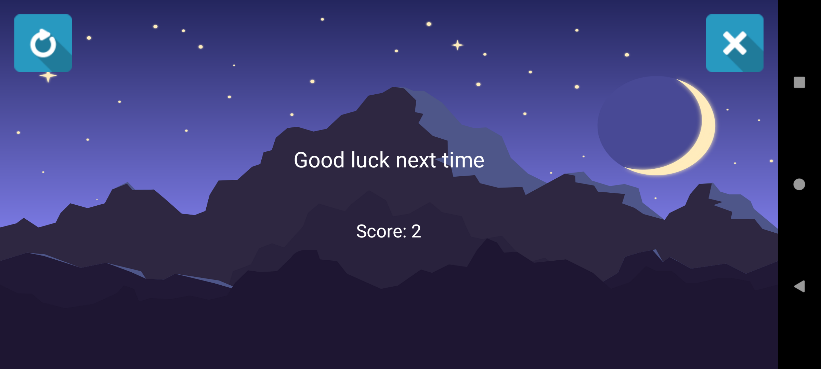

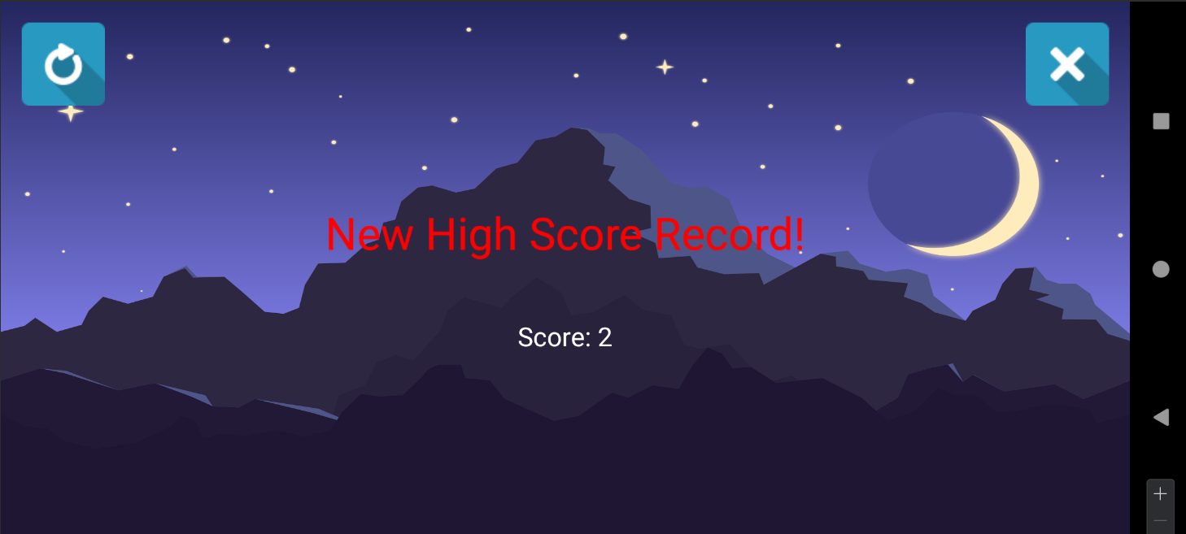

**Source Code**

package com.example.spaceshoot  
  
import android.content.Context  
import android.graphics.Bitmap  
import android.graphics.BitmapFactory  
  
class Bomb(context: Context, var bx: Int, var by: Int) {  
 private var bombBitmap: Bitmap = BitmapFactory.decodeResource(context.*resources*,  
 R.drawable.*bomb* )  
  
 fun getBomb(): Bitmap {  
 return bombBitmap  
 }  
 fun updatePosition(speed: Int) {  
 by += speed  
 }  
}

package com.example.spaceshoot  
  
import android.content.Context  
import android.graphics.Bitmap  
import android.graphics.BitmapFactory  
  
class BombDropCat(private val context: Context) {  
 var ex: Int = 0 // X position  
 var ey: Int = 0 // Y position  
  
 private val spaceshipBitmap: Bitmap by *lazy* **{** BitmapFactory.decodeResource(context.*resources*, R.drawable.*enemycat*)  
 **}** fun getBombDropCatHeight(): Int {  
 return spaceshipBitmap.*height* }  
  
 fun getBombDropCatWidth(): Int {  
 return spaceshipBitmap.*width* }  
  
 fun getBombDropCatBitmap(): Bitmap {  
 return spaceshipBitmap  
 }  
  
}

import android.content.Context  
import android.graphics.Bitmap  
import android.graphics.BitmapFactory  
import com.example.spaceshoot.R  
import java.util.Random  
  
class EnemySpaceship(context: Context) {  
  
 var enemySpaceship: Bitmap? = null  
 var ex = 0  
 var ey = 0  
 var enemyVelocity = 0  
 private val random: Random = Random()  
  
 init {  
 enemySpaceship = BitmapFactory.decodeResource(context.*resources*, R.drawable.*human*)  
 ex = 200 + random.nextInt(400)  
 enemyVelocity = 14 + random.nextInt(10)  
 }  
  
 fun getEnemySpaceshipBitmap(): Bitmap? {  
 return enemySpaceship  
 }  
  
 fun getEnemySpaceshipWidth(): Int {  
 return enemySpaceship?.*width* ?: 0  
 }  
  
 fun getEnemySpaceshipHeight(): Int {  
 return enemySpaceship?.*height* ?: 0  
 }  
}

package com.example.spaceshoot  
  
import android.content.Context  
import android.graphics.Bitmap  
import android.graphics.BitmapFactory  
  
class Explosion(context: Context, var eX: Int, var eY: Int) {  
 private val explosion: Array<Bitmap?> = *arrayOfNulls*(9)  
 var explosionFrame: Int = 0  
  
 init {  
 explosion[0] = BitmapFactory.decodeResource(context.*resources*, R.drawable.*heart9*)  
 explosion[1] = BitmapFactory.decodeResource(context.*resources*, R.drawable.*heart8*)  
 explosion[2] = BitmapFactory.decodeResource(context.*resources*, R.drawable.*heart7*)  
 explosion[3] = BitmapFactory.decodeResource(context.*resources*, R.drawable.*heart6*)  
 explosion[4] = BitmapFactory.decodeResource(context.*resources*, R.drawable.*heart5*)  
 explosion[5] = BitmapFactory.decodeResource(context.*resources*, R.drawable.*heart4*)  
 explosion[6] = BitmapFactory.decodeResource(context.*resources*, R.drawable.*heart3*)  
 explosion[7] = BitmapFactory.decodeResource(context.*resources*, R.drawable.*heart2*)  
 explosion[8] = BitmapFactory.decodeResource(context.*resources*, R.drawable.*heart1*)  
 }  
  
 fun getExplosion(explosionFrame: Int): Bitmap? {  
 return explosion[explosionFrame]  
 }  
}

package com.example.spaceshoot  
import android.view.animation.AnimationUtils  
  
import android.content.Intent  
import android.content.SharedPreferences  
import android.graphics.Color  
import android.media.MediaPlayer  
import android.os.Bundle  
import android.os.Handler  
import android.view.View  
import android.view.animation.Animation  
import android.widget.TextView  
import androidx.appcompat.app.AppCompatActivity  
import java.util.Calendar  
import java.util.Date  
  
@Suppress("DEPRECATION")  
class GameOver : AppCompatActivity() {  
  
 private lateinit var sharedPreferences: SharedPreferences  
 private var points: Int = 0  
 private var mediaPlayer: MediaPlayer? = null  
  
 override fun onCreate(savedInstanceState: Bundle?) {  
 super.onCreate(savedInstanceState)  
 setContentView(R.layout.*game_over*)  
  
 sharedPreferences = getSharedPreferences("MyPrefs", *MODE_PRIVATE*)  
  
 points = *intent*.getIntExtra("points", 0)  
 val message = *intent*.getStringExtra("message") ?: "Game Over"  
 findViewById<TextView>(R.id.*textViewMessage*).*text* = message  
 findViewById<TextView>(R.id.*textViewScore*).*text* = "Score: $points"  
 savePoints(points)  
 }  
  
  
  
  
 private fun savePoints(points: Int) {  
 val scores = retrieveScores().*toMutableList*()  
 var isNewHighScore = false  
 if (scores.isEmpty() || points > scores.*maxOf* **{ it**.score **}**) {  
 isNewHighScore = true  
 }  
 scores.add(Score(points, Calendar.getInstance().*time*))  
  
 val editor = sharedPreferences.edit()  
 editor.putStringSet("scores", scores.*map* **{** "${**it**.score},${**it**.dateTime.*time*}" **}**.*toSet*())  
 editor.apply()  
 if (isNewHighScore) {  
 val textViewMessage = findViewById<TextView>(R.id.*textViewMessage*)  
 val originalTextColor = textViewMessage.*currentTextColor* textViewMessage.setTextColor(Color.*RED*)  
 textViewMessage.*text* = "New High Score Record!"  
 val animation = AnimationUtils.loadAnimation(this, R.anim.*scale_animation*)  
 animation.setAnimationListener(object : Animation.AnimationListener {  
 override fun onAnimationStart(animation: Animation?) {}  
 override fun onAnimationRepeat(animation: Animation?) {}  
 override fun onAnimationEnd(animation: Animation?) {  
 textViewMessage.setTextColor(originalTextColor)  
 }  
  
 })  
  
 textViewMessage.startAnimation(animation)  
  
 Handler().postDelayed(**{** textViewMessage.clearAnimation()  
 **}**, 4000)  
 mediaPlayer = MediaPlayer.create(this, R.raw.*highscore*)  
 mediaPlayer?.start()  
  
 Handler().postDelayed(**{** textViewMessage.clearAnimation()  
 mediaPlayer?.release()  
 mediaPlayer = null  
 **}**, 4000)  
 }  
 }  
 private fun retrieveScores(): Set<Score> {  
 val scoreSet = sharedPreferences.getStringSet("scores", *setOf*()) ?: *setOf*()  
 return scoreSet.*map* **{** score **->** val parts = score.*split*(",")  
 Score(parts[0].*toInt*(), Date(parts[1].*toLong*()))  
 **}**.*toSet*()  
 }  
 fun restart(view: View?) {  
 val intent = Intent(this@GameOver, StartUp::class.*java*)  
 startActivity(intent)  
 finish()  
 }  
 fun exit(view: View?) {  
 finish()  
 }  
}

package com.example.spaceshoot  
  
import android.content.Context  
import android.graphics.Bitmap  
import android.graphics.BitmapFactory  
  
class Life(context: Context, var bx: Int, var by: Int) {  
 private var bombBitmap: Bitmap = BitmapFactory.decodeResource(context.*resources*, R.drawable.*life*)  
  
 fun getLife(): Bitmap {  
 return bombBitmap  
 }  
 fun updatePosition(speed: Int) {  
 by += speed  
 }  
}

package com.example.spaceshoot  
  
import androidx.appcompat.app.AppCompatActivity  
import android.os.Bundle  
  
class MainActivity : AppCompatActivity() {  
 override fun onCreate(savedInstanceState: Bundle?) {  
 super.onCreate(savedInstanceState)  
 setContentView(SpaceShooter(this))  
 }  
  
 override fun onDestroy() {  
 super.onDestroy()  
 }  
  
 override fun onPause() {  
 super.onPause()  
 }  
}

package com.example.spaceshoot  
  
  
import android.content.SharedPreferences  
import android.os.Bundle  
import android.view.View  
import android.widget.Toast  
import androidx.appcompat.app.AppCompatActivity  
import androidx.recyclerview.widget.LinearLayoutManager  
import androidx.recyclerview.widget.RecyclerView  
import java.util.*  
  
class MatchHistory : AppCompatActivity() {  
  
 private lateinit var recyclerView: RecyclerView  
 private lateinit var adapter: ScoreAdapter  
 private lateinit var sharedPreferences: SharedPreferences  
  
 override fun onCreate(savedInstanceState: Bundle?) {  
 super.onCreate(savedInstanceState)  
 setContentView(R.layout.*activity_match_history*)  
  
 recyclerView = findViewById(R.id.*recyclerView*)  
 recyclerView.*layoutManager* = LinearLayoutManager(this)  
  
 // Retrieve and display scores  
 val scores = retrieveScores()  
 adapter = ScoreAdapter(scores)  
 recyclerView.*adapter* = adapter  
  
 sharedPreferences = getSharedPreferences("MyPrefs", *MODE_PRIVATE*)  
  
 }  
  
 private fun retrieveScores(): List<Score> {  
 val sharedPreferences = getSharedPreferences("MyPrefs", *MODE_PRIVATE*)  
 val scoreSet = sharedPreferences.getStringSet("scores", *setOf*()) ?: *setOf*()  
 return scoreSet.*map* **{** score **->** val parts = score.*split*(",")  
 Score(parts[0].*toInt*(), Date(parts[1].*toLong*()))  
 **}**.*sortedByDescending* **{ it**.dateTime **}** }  
 fun clearHistory(view: View) {  
 val editor = sharedPreferences.edit()  
 editor.remove("scores")  
 editor.apply()  
 adapter.updateScores(*emptyList*())  
 Toast.makeText(this, "Match history cleared!", Toast.*LENGTH_SHORT*).show()  
 }  
  
  
 fun resetHighScore(view: View) {  
 val editor = sharedPreferences.edit()  
 editor.putInt("highestScore", 0) // Reset highest score to 0  
 editor.apply()  
 Toast.makeText(this, "Score Set to 0", Toast.*LENGTH_SHORT*).show()  
 }  
  
 fun goBack(view: View) {  
 onBackPressed()  
 }  
}

package com.example.spaceshoot  
  
import android.content.Context  
import android.graphics.Bitmap  
import android.graphics.BitmapFactory  
import java.util.Random  
  
  
  
class OurSpaceship(context: Context) {  
 var ourSpaceship: Bitmap? = null  
 var ox: Int = 0  
 var oy: Int = 0  
 private val random: Random = Random()  
  
 init {  
 ourSpaceship = BitmapFactory.decodeResource(context.*resources*, R.drawable.*cat*);  
 ox = random.nextInt(SpaceShooter.screenWidth)  
 oy = SpaceShooter.screenHeight - ourSpaceship!!.*height* }  
  
 fun getOurSpaceshipBitmap(): Bitmap? {  
 return ourSpaceship  
 }  
  
 fun getOurSpaceshipWidth(): Int {  
 return ourSpaceship!!.*width* }  
 fun getOurSpaceshipHeight(): Int {  
 return ourSpaceship!!.*height* }  
}

package com.example.spaceshoot  
  
import java.util.Date  
  
data class Score(val score: Int, val dateTime: Date)

package com.example.spaceshoot  
  
  
import android.annotation.SuppressLint  
import android.view.LayoutInflater  
import android.view.View  
import android.view.ViewGroup  
import android.widget.TextView  
import androidx.recyclerview.widget.RecyclerView  
import java.text.SimpleDateFormat  
import java.util.*  
  
class ScoreAdapter(private var scores: List<Score>) : RecyclerView.Adapter<ScoreAdapter.ScoreViewHolder>() {  
  
 override fun onCreateViewHolder(parent: ViewGroup, viewType: Int): ScoreViewHolder {  
 val itemView = LayoutInflater.from(parent.*context*).inflate(R.layout.*item_score*, parent, false)  
 return ScoreViewHolder(itemView)  
 }  
  
 override fun onBindViewHolder(holder: ScoreViewHolder, position: Int) {  
 val score = scores[position]  
 holder.bind(score)  
 }  
  
 override fun getItemCount(): Int = scores.size  
  
 inner class ScoreViewHolder(itemView: View) : RecyclerView.ViewHolder(itemView) {  
 private val textViewScore: TextView = itemView.findViewById(R.id.*textViewScore*)  
 private val textViewDateTime: TextView = itemView.findViewById(R.id.*textViewDateTime*)  
  
 @SuppressLint("SetTextI18n")  
 fun bind(score: Score) {  
 val dateFormat = SimpleDateFormat("dd-MM-yyyy HH:mm:ss", Locale.getDefault())  
 textViewScore.*text* = "Score : ${score.score}"  
 textViewDateTime.*text* = dateFormat.format(score.dateTime)  
 }  
  
 }  
 @SuppressLint("NotifyDataSetChanged")  
 fun updateScores(newScores: List<Score>) {  
 scores = newScores  
 notifyDataSetChanged()  
 }  
  
}

package com.example.spaceshoot  
  
import android.content.Context  
import android.graphics.Bitmap  
import android.graphics.BitmapFactory  
  
class Shot(context: Context, var shx: Int, var shy: Int) {  
 private val shot: Bitmap = BitmapFactory.decodeResource(context.*resources*, R.drawable.*fish*)  
  
  
 fun getShot(): Bitmap {  
 return shot  
 }  
  
 fun getShotWidth(): Int {  
 return shot.*width* }  
  
 fun getShotHeight(): Int {  
 return shot.*height* }  
}

package com.example.spaceshoot  
  
import EnemySpaceship  
import android.annotation.SuppressLint  
import android.app.Activity  
import android.content.Context  
import android.content.Intent  
import android.graphics.Bitmap  
import android.graphics.BitmapFactory  
import android.graphics.Canvas  
import android.graphics.Color  
import android.graphics.Paint  
import android.graphics.Point  
import android.graphics.Rect  
import android.graphics.Typeface  
import android.os.Handler  
import android.os.Looper  
import android.view.Display  
import android.view.MotionEvent  
import android.view.View  
import androidx.appcompat.app.AppCompatActivity  
import java.util.Random  
import android.os.CountDownTimer  
import android.media.MediaPlayer  
  
@Suppress("DEPRECATION")  
class SpaceShooter(context: Context) : View(context) {  
 private var lifeCatchplayer: MediaPlayer? = null  
 private var explosionmediaPlayer: MediaPlayer? = null  
 private var bombexplosionmediaPlayer: MediaPlayer? = null  
 private var pauseButtonRect: Rect? = null  
 private var pauseButtonText = "Pause"  
 private val pauseButtonPaint = Paint().*apply* **{** *color* = Color.*WHITE  
 textSize* = 40f  
 *typeface* = Typeface.*DEFAULT_BOLD* **}** private var bombs: ArrayList<Bomb>? = ArrayList()  
 private var background: Bitmap  
 private var lifeImage: Bitmap  
 private var mHandler: Handler = Handler(Looper.getMainLooper())  
 val UPDATE_MILLIS: Long = 30  
 companion object {  
 var screenWidth: Int = 0  
 var screenHeight: Int = 0  
 }  
 private val maxDescentHeight: Int = screenHeight / 6  
 private var bombDropCat: BombDropCat? = BombDropCat(context)  
 private var showBombDropCat: Boolean = false  
 private var bombDropped: Boolean = false  
 private var lastAppearanceTime: Long = System.currentTimeMillis()  
 private var appearanceInterval: Long = 20000  
 private var enemyShotInterval: Long = 2000  
 private var bulletSpeed: Int = 15  
 private var enemyShotCollisionOccurred = false  
 private var gameTimer: CountDownTimer? = null  
 private var gameTimeInSeconds: Long = 0  
 private var points: Int = 0  
 private var life: Int = 3  
 private var scorePaint: Paint? = null  
 private var TEXT_SIZE = 45  
 private var paused = false  
 private var ourSpaceship: OurSpaceship? = null  
 private var enemySpaceship: EnemySpaceship? = null  
 private var enemyShots: ArrayList<Shot>? = null  
 private var ourShots: ArrayList<Shot?>? = null  
 private var random: Random? = null  
 private var explosion: Explosion? = null  
 private var explosions: ArrayList<Explosion>? = null  
 private var enemyShotAction = false  
 private val runnable = *Runnable* **{** invalidate() **}** private var gameOver = false  
 private var isHitThisFrame = false  
 private var outOfScreenMediaPlayer: MediaPlayer? = null  
 private var lives: ArrayList<Life>? = null  
 private var lastBombDropTime: Long = System.currentTimeMillis()  
 private val bombDropInterval: Long = 10000  
 private val bombDropChance: Double = 0.5  
 private var highestScore: Int = 0  
 private var bombexplosions: ArrayList<BombExplosion> = ArrayList()  
  
  
  
 init {  
 bombexplosionmediaPlayer =MediaPlayer.create(context, R.raw.*catcry*)  
 loadHighestScore()  
 lives = ArrayList()  
 outOfScreenMediaPlayer = MediaPlayer.create(context, R.raw.*out_of_screen_sound*)  
 explosionmediaPlayer = MediaPlayer.create(context, R.raw.*explosion*)  
 lifeCatchplayer = MediaPlayer.create(context, R.raw.*levelupsound*)  
 val display: Display = (context as AppCompatActivity).*windowManager*.*defaultDisplay* val size = Point().*apply* **{** display.getSize(this) **}** screenWidth = size.x  
 screenHeight = size.y  
 random = Random()  
 enemyShots = ArrayList()  
 ourShots = ArrayList()  
 explosions = ArrayList()  
 ourSpaceship = OurSpaceship(context)  
 enemySpaceship = EnemySpaceship(context)  
 mHandler= Handler()  
 background = BitmapFactory.decodeResource(context.*resources*, R.drawable.*gameplaybackground3*)  
 lifeImage = BitmapFactory.decodeResource(context.*resources*, R.drawable.*life*)  
 scorePaint = Paint()  
 scorePaint!!.*color* = Color.*RED* scorePaint!!.*textSize* = TEXT_SIZE.toFloat()  
 scorePaint!!.*textAlign* = Paint.Align.*LEFT* startGameTimer()  
  
 val buttonWidth = 100  
 val buttonHeight = 100  
 val buttonRight = screenWidth - 30  
 val buttonBottom = screenHeight - 30  
 val buttonLeft = buttonRight - buttonWidth  
 val buttonTop = buttonBottom - buttonHeight  
  
 pauseButtonRect = Rect(buttonLeft, buttonTop, buttonRight, buttonBottom)  
  
 background = getFullScreenBitmap(  
 BitmapFactory.decodeResource(context.*resources*, R.drawable.*gameplaybackground3*),  
 screenWidth,  
 screenHeight  
 )  
 }  
  
  
  
 @SuppressLint("DrawAllocation")  
 override fun onDraw(canvas: Canvas) {  
 isHitThisFrame = false  
 canvas.drawBitmap(background, 0f, 0f, null)  
  
 canvas.drawText("Score: $points", 0f, TEXT_SIZE.toFloat(), scorePaint!!)  
 val smallerTextSize = (TEXT_SIZE * 0.8).toFloat()  
 scorePaint!!.*textSize* = smallerTextSize  
 canvas.drawText("High Score: $highestScore", 0f, TEXT_SIZE * 2.toFloat(), scorePaint!!)  
  
 scorePaint!!.*textSize* = TEXT_SIZE.toFloat()  
  
 for (i in life *downTo* 1) {  
 canvas.drawBitmap(lifeImage, (screenWidth - lifeImage.*width* * i).toFloat(), 0f, null)  
 }  
  
  
 val gameTimeText = "Time: ${formatTime(gameTimeInSeconds)}"  
 val textX = TEXT_SIZE.toFloat()-40  
 val textY = (screenHeight - TEXT_SIZE / 2).toFloat()  
 canvas.drawText(gameTimeText, textX, textY, scorePaint!!)  
  
  
  
 if (pauseButtonRect == null) {  
 pauseButtonRect = Rect(50, 50, 350, 150)  
 }  
  
  
 // Draw the button  
 pauseButtonRect?.*let* **{** val textBounds = Rect()  
 pauseButtonPaint.getTextBounds(pauseButtonText, 0, pauseButtonText.length, textBounds)  
 val x = **it**.left + (**it**.width() - textBounds.width()) / 2  
 val y = **it**.top + (**it**.height() + textBounds.height()) / 2 - textBounds.bottom  
 canvas.drawText(pauseButtonText, x.toFloat(), y.toFloat(), pauseButtonPaint)  
 **}** tryShootingEnemyBullet()  
 if (life <= 0 && !gameOver) {  
 gameOver = true  
 paused = true  
 mHandler.removeCallbacks(runnable)  
 val message =  
 if(points>=10) "Excellent Job"  
 else if (points >= 5) "Good Job"  
 else "Good luck next time"  
 transitionToGameOver(message)  
 }  
 updateBombDropCat()  
 if (showBombDropCat) {  
 canvas.drawBitmap(bombDropCat!!.getBombDropCatBitmap(), bombDropCat!!.ex.toFloat(), bombDropCat!!.ey.toFloat(), null)  
 }  
  
 updateBombs(15)  
  
 val bombIterator = bombs!!.iterator()  
 while (bombIterator.hasNext()) {  
 val bomb = bombIterator.next()  
 if (checkCollisionWithBomb(bomb)) {  
 life -= 2  
 bombIterator.remove()  
 bombexplosionmediaPlayer?.start()  
 }  
 }  
 // Draw each bomb  
 bombs?.*forEach* **{** bomb **->** canvas.drawBitmap(bomb.getBomb(), bomb.bx.toFloat(), bomb.by.toFloat(), null)  
 **}** tryDroppingBomb()  
  
 // Life Drop  
 val lifeiterator = lives!!.iterator()  
 while (lifeiterator.hasNext()) {  
 val bomb = lifeiterator.next()  
 bomb.updatePosition(5)  
  
 // Draw the bomb  
 canvas.drawBitmap(bomb.getLife(), bomb.bx.toFloat(), bomb.by.toFloat(), null)  
  
  
 if (checkCollision(ourSpaceship!!, bomb)) {  
 if (life < 5) {  
 life++  
 lifeCatchplayer?.start()  
 }  
 lifeiterator.remove()  
 }  
  
 // Remove bomb if it goes off screen  
 if (bomb.by > screenHeight) {  
 lifeiterator.remove()  
 }  
 }  
  
  
  
  
  
 // Move enemySpaceship  
 enemySpaceship!!.ex += enemySpaceship!!.enemyVelocity  
 if (enemySpaceship!!.ex + enemySpaceship!!.getEnemySpaceshipWidth() >= screenWidth) {  
 enemySpaceship!!.enemyVelocity *= -1  
 }  
 if (enemySpaceship!!.ex <= 0) {  
 enemySpaceship!!.enemyVelocity *= -1  
 }  
 if (!enemyShotAction) {  
 if (enemySpaceship!!.ex >= 200 + random!!.nextInt(400) && enemySpaceship!!.ey >= 200 + random!!.nextInt(400)) {  
 val enemyShot = Shot(  
 *context*,  
 enemySpaceship!!.ex + enemySpaceship!!.getEnemySpaceshipWidth() / 2,  
 enemySpaceship!!.ey  
 )  
 enemyShots!!.add(enemyShot)  
 enemyShotAction = true  
 }  
 enemyShotAction = if (enemySpaceship!!.ex >= 400 + random!!.nextInt(800) && enemySpaceship!!.ey >= 400 + random!!.nextInt(800)) {  
 val enemyShot = Shot(  
 *context*,  
 enemySpaceship!!.ex + enemySpaceship!!.getEnemySpaceshipWidth() / 2,  
 enemySpaceship!!.ey  
 )  
 enemyShots!!.add(enemyShot)  
 true  
 } else {  
 val enemyShot = Shot(  
 *context*,  
 enemySpaceship!!.ex + enemySpaceship!!.getEnemySpaceshipWidth() / 2,  
 enemySpaceship!!.ey  
 )  
 enemyShots!!.add(enemyShot)  
 true  
 }  
 }  
 // Draw the enemy Spaceship  
 canvas.drawBitmap(  
 enemySpaceship!!.getEnemySpaceshipBitmap()!!,  
 enemySpaceship!!.ex.toFloat(),  
 enemySpaceship!!.ey.toFloat(),  
 null  
 )  
  
 if (ourSpaceship!!.ox > screenWidth - ourSpaceship!!.getOurSpaceshipWidth()) {  
 ourSpaceship!!.ox = screenWidth - ourSpaceship!!.getOurSpaceshipWidth()  
 } else if (ourSpaceship!!.ox < 0) {  
 ourSpaceship!!.ox = 0  
 }  
 // Draw our Spaceship  
 canvas.drawBitmap(  
 ourSpaceship!!.getOurSpaceshipBitmap()!!,  
 ourSpaceship!!.ox.toFloat(),  
 ourSpaceship!!.oy.toFloat(),  
 null  
 )  
  
 val it = bombexplosions.iterator()  
 while (it.hasNext()) {  
 val explosion = it.next()  
 val bitmap = explosion.getBombExplosion(explosion.explosionFrame)  
 if (bitmap != null) {  
 canvas.drawBitmap(bitmap, explosion.eX.toFloat(), explosion.eY.toFloat(), null)  
 explosion.explosionFrame++  
 if (explosion.explosionFrame >= explosion.explosion.size) {  
 it.remove() // Remove the explosion after the last frame is shown  
 }  
 }  
 }  
 val iterator = enemyShots!!.iterator()  
 while (iterator.hasNext()) {  
 val enemyShot = iterator.next()  
 enemyShot.shy += bulletSpeed  
 canvas.drawBitmap(enemyShot.getShot(), enemyShot.shx.toFloat(), enemyShot.shy.toFloat(), null)  
  
 // Check for collisions with our spaceship  
 if (!isHitThisFrame && enemyShot.shx >= ourSpaceship!!.ox && enemyShot.shx <= ourSpaceship!!.ox + ourSpaceship!!.getOurSpaceshipWidth() &&  
 enemyShot.shy >= ourSpaceship!!.oy && enemyShot.shy <= ourSpaceship!!.oy + ourSpaceship!!.getOurSpaceshipHeight()) {  
 explosionmediaPlayer?.start()  
 points++  
 isHitThisFrame = true  
 iterator.remove()  
 explosion = Explosion(*context*, ourSpaceship!!.ox, ourSpaceship!!.oy)  
 explosions!!.add(explosion!!)  
 enemyShotCollisionOccurred = true  
 continue  
 }  
  
 if (enemyShot.shy >= screenHeight) {  
 iterator.remove()  
 life--  
 outOfScreenMediaPlayer?.start()  
 }  
 }  
  
 if (enemyShots!!.isEmpty()) {  
 enemyShotAction = false  
 }  
  
 for (i in ourShots!!.*indices*) {  
 ourShots!![i]!!.shy -= 15  
 canvas.drawBitmap(  
 ourShots!![i]!!.getShot(),  
 ourShots!![i]!!.shx.toFloat(),  
 ourShots!![i]!!.shy.toFloat(),  
 null  
 )  
 if (ourShots!![i]!!.shx >= enemySpaceship!!.ex &&  
 ourShots!![i]!!.shx <= enemySpaceship!!.ex + enemySpaceship!!.getEnemySpaceshipWidth() &&  
 ourShots!![i]!!.shy >= enemySpaceship!!.ey &&  
 ourShots!![i]!!.shy <= enemySpaceship!!.ey + enemySpaceship!!.getEnemySpaceshipHeight()) {  
 // Collision detected  
 points++  
 ourShots!!.removeAt(i)  
 explosion = Explosion(*context*, enemySpaceship!!.ex, enemySpaceship!!.ey)  
 explosions!!.add(explosion!!)  
 } else if (ourShots!![i]!!.shy <= 0) {  
 ourShots!!.removeAt(i)  
 }  
 }  
  
 // Do the explosion  
 for (i in explosions!!.*indices*.*reversed*()) {  
 canvas.drawBitmap(  
 explosions!![i].getExplosion(explosions!![i].explosionFrame)!!,  
 explosions!![i].eX.toFloat(),  
 explosions!![i].eY.toFloat(),  
 null  
 )  
 explosions!![i].explosionFrame++  
 if (explosions!![i].explosionFrame > 8) {  
 explosions!!.removeAt(i)  
 }  
 }  
 if (!paused && !gameOver) {  
 scheduleNextFrame()  
 }  
 tryDroppingLife()  
  
 }  
  
 @SuppressLint("ClickableViewAccessibility")  
 override fun onTouchEvent(event: MotionEvent): Boolean {  
 val x = event.*x*.toInt()  
 val y = event.*y*.toInt()  
  
 pauseButtonRect?.*let* **{** if (x >= **it**.left && x <= **it**.right && y >= **it**.top && y <= **it**.bottom) {  
 if (event.*action* == MotionEvent.*ACTION_DOWN*) {  
  
 if (paused) {  
 resumeGame()  
 } else {  
 pauseGame()  
 }  
 return true  
 }  
 }  
 **}** // Handle other touch events for gameplay  
 if (!paused) {  
 // Move ourSpaceship on ACTION_DOWN or ACTION_MOVE  
 if (event.*action* == MotionEvent.*ACTION_DOWN* || event.*action* == MotionEvent.*ACTION_MOVE*) {  
 ourSpaceship!!.ox = x.*coerceIn*(0, screenWidth - ourSpaceship!!.getOurSpaceshipWidth())  
 }  
 }  
  
 return true  
 }  
  
  
 fun pauseGame() {  
 if (!paused) {  
 paused = true  
 pauseButtonText = "Play"  
 mHandler.removeCallbacks(runnable)  
 gameTimer?.cancel()  
 invalidate()  
 }  
 }  
  
 fun resumeGame() {  
 if (paused) {  
 paused = false  
 pauseButtonText = "Pause"  
 gameTimer?.start()  
 scheduleNextFrame()  
 invalidate()  
 }  
 }  
  
 private fun scheduleNextFrame() {  
 mHandler.removeCallbacks(runnable)  
 if (!paused) {  
 mHandler.postDelayed(runnable, UPDATE_MILLIS)  
 }  
 }  
  
 private var lastShotTime = System.currentTimeMillis()  
  
 private fun tryShootingEnemyBullet() {  
 val currentTime = System.currentTimeMillis()  
 if (currentTime - lastShotTime > enemyShotInterval && !paused && !enemyShotCollisionOccurred) {  
 createEnemyBullet()  
 lastShotTime = currentTime  
 }  
 }  
 private fun createEnemyBullet() {  
 if (!gameOver && enemySpaceship != null) {  
 val shot = Shot(  
 *context*,  
 enemySpaceship!!.ex + enemySpaceship!!.getEnemySpaceshipWidth() / 2,  
 enemySpaceship!!.ey  
 )  
 enemyShots!!.add(shot)  
 }  
 }  
  
 private fun tryDroppingLife() {  
 val currentTime = System.currentTimeMillis()  
 if (currentTime - lastBombDropTime > bombDropInterval && Math.random() < bombDropChance && life < 5 && !paused && !gameOver) {  
 dropLife()  
 lastBombDropTime = currentTime  
 }  
 }  
  
 private fun dropLife() {  
  
 val life = Life(*context*, enemySpaceship!!.ex + enemySpaceship!!.getEnemySpaceshipWidth() / 2, enemySpaceship!!.ey)  
 lives!!.add(life)  
 }  
  
 private fun checkCollision(ourSpaceship: OurSpaceship, life: Life): Boolean {  
 return life.bx + life.getLife().*width* > ourSpaceship.ox &&  
 life.bx < ourSpaceship.ox + ourSpaceship.getOurSpaceshipWidth() &&  
 life.by + life.getLife().*height* > ourSpaceship.oy &&  
 life.by < ourSpaceship.oy + ourSpaceship.getOurSpaceshipHeight()  
 }  
  
 private fun dropBomb() {  
 val bomb = Bomb(*context*, enemySpaceship!!.ex + enemySpaceship!!.getEnemySpaceshipWidth() / 2, enemySpaceship!!.ey)  
 bombs!!.add(bomb)  
 }  
  
 private fun updateBombs(speed: Int) {  
 val iterator = bombs!!.iterator()  
 while (iterator.hasNext()) {  
 val bomb = iterator.next()  
 bomb.updatePosition(speed)  
  
  
 if (bomb.by > screenHeight) {  
 iterator.remove()  
 }  
 }  
 }  
  
 private fun tryDroppingBomb() {  
 val currentTime = System.currentTimeMillis()  
 if (currentTime - lastBombDropTime > bombDropInterval && Math.random() < bombDropChance && !paused && !gameOver) {  
 dropBomb()  
 lastBombDropTime = currentTime // Reset the timer  
 }  
 }  
  
 private fun checkCollisionWithBomb(bomb: Bomb): Boolean {  
 val bombRect = Rect(bomb.bx, bomb.by, bomb.bx + bomb.getBomb().*width*, bomb.by + bomb.getBomb().*height*)  
 val spaceshipRect = Rect(  
 ourSpaceship!!.ox,  
 ourSpaceship!!.oy,  
 ourSpaceship!!.ox + ourSpaceship!!.getOurSpaceshipWidth(),  
 ourSpaceship!!.oy + ourSpaceship!!.getOurSpaceshipHeight()  
 )  
  
 if (Rect.intersects(bombRect, spaceshipRect)) {  
 bombexplosions.add(BombExplosion(*context*, ourSpaceship!!.ox, ourSpaceship!!.oy))  
 return true  
 }  
 return false  
 }  
  
  
 private fun updateBombDropCat() {  
 if (!showBombDropCat && shouldAppear()) {  
 bombDropCat!!.ex = Random().nextInt(screenWidth - bombDropCat!!.getBombDropCatWidth())  
 bombDropCat!!.ey = -bombDropCat!!.getBombDropCatHeight()  
 showBombDropCat = true  
 bombDropped = false  
 }  
  
 if (showBombDropCat) {  
  
 if (bombDropCat!!.ey < maxDescentHeight && !bombDropped) {  
 bombDropCat!!.ey += 10  
 } else if (!bombDropped && bombDropCat!!.ey >= 0) {  
  
 dropBombFromCat()  
 bombDropped = true  
 }  
  
  
 if (bombDropped) {  
 bombDropCat!!.ey -= 10 // Move up  
 if (bombDropCat!!.ey <= -bombDropCat!!.getBombDropCatHeight()) {  
 showBombDropCat = false  
 lastAppearanceTime = System.currentTimeMillis()  
 }  
 }  
 }  
 }  
  
 private fun dropBombFromCat() {  
 if (bombDropCat!!.ey in 0..screenHeight) {  
 val bomb = Bomb(*context*, bombDropCat!!.ex + bombDropCat!!.getBombDropCatWidth() / 2, bombDropCat!!.ey)  
 bombs!!.add(bomb)  
 }  
 }  
  
 private fun loadHighestScore() {  
 val sharedPreferences = *context*.getSharedPreferences("MyPrefs", Context.*MODE_PRIVATE*)  
 highestScore = sharedPreferences.getInt("highestScore", 0)  
 }  
  
 private fun shouldAppear(): Boolean {  
 val currentTime = System.currentTimeMillis()  
 return currentTime - lastAppearanceTime > appearanceInterval && Math.random() < 0.5  
 }  
 private fun updateHighestScore() {  
 if (points > highestScore) {  
 highestScore = points  
 val sharedPreferences = *context*.getSharedPreferences("MyPrefs", Context.*MODE_PRIVATE*)  
 val editor = sharedPreferences.edit()  
 editor.putInt("highestScore", highestScore)  
 editor.apply()  
 }  
 }  
  
 private fun startGameTimer() {  
 gameTimer = object : CountDownTimer(Long.MAX_VALUE, 1000) {  
 override fun onTick(millisUntilFinished: Long) {  
 gameTimeInSeconds++  
 if ((gameTimeInSeconds % 5).toInt() == 0) {  
 enemyShotInterval -= 200  
 bulletSpeed += 2  
 if (enemyShotInterval < 500) {  
 enemyShotInterval = 500  
 }  
 if (bulletSpeed > 70) {  
 bulletSpeed = 70  
 }  
 }  
 }  
  
 override fun onFinish() {  
  
 }  
 }  
 gameTimer?.start()  
 }  
  
 private fun transitionToGameOver(message: String) {  
 val intent = Intent(*context*, GameOver::class.*java*)  
 updateHighestScore()  
 intent.putExtra("points", points)  
 intent.putExtra("message", message)  
 *context*.startActivity(intent)  
 (*context* as Activity).finish()  
 }  
  
 private fun formatTime(seconds: Long): String {  
 val minutes = seconds / 60  
 val remainingSeconds = seconds % 60  
 return String.*format*("%02d:%02d", minutes, remainingSeconds)  
 }  
  
 private fun getFullScreenBitmap(bitmap: Bitmap, width: Int, height: Int): Bitmap {  
 return Bitmap.createScaledBitmap(bitmap, width, height, true)  
 }  
  
  
 override fun onDetachedFromWindow() {  
 super.onDetachedFromWindow()  
 lifeCatchplayer?.release()  
 explosionmediaPlayer?.release()  
 bombexplosionmediaPlayer?.release()  
 outOfScreenMediaPlayer?.release()  
  
 lifeCatchplayer = null  
 explosionmediaPlayer = null  
 outOfScreenMediaPlayer = null  
 bombexplosionmediaPlayer = null  
 }  
  
  
  
}

package com.example.spaceshoot  
import android.content.Intent  
import android.os.Bundle  
import android.view.View  
import androidx.appcompat.app.AppCompatActivity  
class StartUp : AppCompatActivity() {  
 override fun onCreate(savedInstanceState: Bundle?) {  
 super.onCreate(savedInstanceState)  
 setContentView(R.layout.*startup*)  
 }  
  
 fun startGame(view: View) {  
 startActivity(Intent(this, MainActivity::class.*java*))  
 finish()  
 }  
  
 fun openMatchHistory(view: View) {  
 val intent = Intent(this, MatchHistory::class.*java*)  
 startActivity(intent)  
 }  
}

**Animation Code**

<?xml version="1.0" encoding="utf-8"?>  
<scale xmlns:android="http://schemas.android.com/apk/res/android"  
 android:fromXScale="1.0"  
 android:toXScale="1.5"  
 android:fromYScale="1.0"  
 android:toYScale="1.5"  
 android:duration="500"  
 android:pivotX="50%"  
 android:pivotY="50%"  
 android:repeatMode="reverse"  
 android:repeatCount="infinite"  
 android:interpolator="@android:anim/accelerate_decelerate_interpolator"/>

**Layout Files**

<?xml version="1.0" encoding="utf-8"?>  
<androidx.constraintlayout.widget.ConstraintLayout xmlns:android="http://schemas.android.com/apk/res/android"  
 xmlns:app="http://schemas.android.com/apk/res-auto"  
 xmlns:tools="http://schemas.android.com/tools"  
 android:layout_width="match_parent"  
 android:layout_height="match_parent"  
 tools:context=".MainActivity">  
  
  
</androidx.constraintlayout.widget.ConstraintLayout>

<?xml version="1.0" encoding="utf-8"?>  
<RelativeLayout xmlns:android="http://schemas.android.com/apk/res/android"  
 android:layout_width="match_parent"  
 android:layout_height="match_parent"  
 android:background="@drawable/background1">  
  
 <ImageButton  
 android:id="@+id/btnBack"  
 android:layout_width="wrap_content"  
 android:layout_height="wrap_content"  
 android:src="@drawable/baseline_arrow_back_ios_new_24"  
 android:background="?android:attr/selectableItemBackground"  
 android:padding="8dp"  
 android:layout_alignParentStart="true"  
 android:layout_alignParentTop="true"  
 android:layout_margin="16dp"  
 android:onClick="goBack" />  
  
 <TextView  
 android:id="@+id/textViewTitle"  
 android:layout_width="wrap_content"  
 android:layout_height="wrap_content"  
 android:text="@string/match_history"  
 android:textSize="24sp"  
 android:textStyle="bold"  
 android:layout_marginTop="40dp"  
 android:layout_marginBottom="20dp"  
 android:layout_centerHorizontal="true"/>  
  
 <androidx.recyclerview.widget.RecyclerView  
 android:id="@+id/recyclerView"  
 android:layout_width="match_parent"  
 android:layout_height="match_parent"  
 android:layout_below="@id/textViewTitle"  
 android:layout_above="@+id/btnClearHistory"  
 android:padding="16dp" />  
  
 <Button  
 android:id="@+id/btnClearHistory"  
 android:layout_width="wrap_content"  
 android:layout_height="wrap_content"  
 android:text="@string/clear_history"  
 android:layout_alignParentBottom="true"  
 android:layout_marginTop="20dp"  
 android:onClick="clearHistory" />  
  
 <Button  
 android:id="@+id/resetHighScoreButton"  
 android:layout_width="wrap_content"  
 android:layout_height="wrap_content"  
 android:text="Reset High Score"  
 android:layout_toRightOf="@id/btnClearHistory" android:layout_alignBaseline="@id/btnClearHistory" android:layout_marginLeft="16dp" android:onClick="resetHighScore" />  
  
</RelativeLayout>

<?xml version="1.0" encoding="utf-8"?>  
<LinearLayout xmlns:android="http://schemas.android.com/apk/res/android"  
 android:orientation="vertical"  
 android:background="@drawable/background2"  
 android:layout_width="match_parent"  
 android:layout_height="match_parent"  
 android:padding="16dp">  
 <LinearLayout  
 android:layout_width="wrap_content"  
 android:layout_height="wrap_content"  
 android:orientation="horizontal"  
 >  
 <ImageButton  
 android:layout_width="wrap_content"  
 android:layout_height="wrap_content"  
 android:background="@drawable/restart"  
 android:onClick="restart"/>  
 <View  
 android:layout_width="0dp"  
 android:layout_height="0dp"  
 android:layout_weight="1"/>  
 <ImageButton  
 android:layout_width="wrap_content"  
 android:layout_height="wrap_content"  
 android:background="@drawable/exit"  
 android:onClick="exit"/>  
  
  
  
 </LinearLayout>  
 <LinearLayout  
 android:layout_width="match_parent"  
 android:layout_height="match_parent"  
 android:layout_gravity="center"  
 android:gravity="center"  
 android:orientation="vertical"  
 android:layout_marginBottom="64dp"  
 >  
 <TextView  
 android:id="@+id/textViewMessage"  
 android:layout_width="wrap_content"  
 android:layout_height="wrap_content"  
 android:textSize="24sp"  
 android:textColor="#FFFFFF"  
 android:layout_marginTop="20dp" />  
  
 <TextView  
 android:id="@+id/textViewScore"  
 android:layout_width="wrap_content"  
 android:layout_height="wrap_content"  
 android:textSize="20sp"  
 android:textColor="#FFFFFF"  
 android:layout_marginTop="50dp" />  
  
  
 </LinearLayout>  
 <ImageView  
 android:id="@+id/paperView"  
 android:layout_width="wrap_content"  
 android:layout_height="wrap_content"  
 android:src="@drawable/play_big"  
 android:visibility="invisible" />  
  
</LinearLayout>

<?xml version="1.0" encoding="utf-8"?>  
<LinearLayout xmlns:android="http://schemas.android.com/apk/res/android"  
 android:layout_width="match_parent"  
 android:layout_height="wrap_content"  
 android:orientation="vertical"  
 android:padding="8dp">  
  
 <TextView  
 android:id="@+id/textViewScore"  
 android:layout_width="wrap_content"  
 android:layout_height="wrap_content"  
 android:textSize="18sp"  
 android:textColor="@android:color/black"  
 android:background="@android:color/transparent"/>  
  
 <TextView  
 android:id="@+id/textViewDateTime"  
 android:layout_width="wrap_content"  
 android:layout_height="wrap_content"  
 android:textSize="10sp"  
 android:textColor="@android:color/black"  
 android:background="@android:color/transparent"/>  
  
  
 <View  
 android:layout_width="1dp"  
 android:layout_height="match_parent"  
 android:background="@android:color/darker_gray"  
 android:layout_marginStart="8dp"  
 android:layout_marginEnd="8dp"  
 android:elevation="1dp"/>  
  
</LinearLayout>

<?xml version="1.0" encoding="utf-8"?>  
<RelativeLayout xmlns:android="http://schemas.android.com/apk/res/android"  
 android:layout_width="match_parent"  
 android:layout_height="match_parent"  
 android:background="@drawable/background1">  
  
  
 <LinearLayout  
 android:id="@+id/playButtonLayout"  
 android:layout_width="wrap_content"  
 android:layout_height="wrap_content"  
 android:orientation="vertical"  
 android:layout_centerInParent="true">  
  
 <ImageButton  
 android:layout_width="wrap_content"  
 android:layout_height="wrap_content"  
 android:background="@drawable/play_big"  
 android:onClick="startGame" />  
  
 <TextView  
 android:layout_width="wrap_content"  
 android:layout_height="wrap_content"  
 android:layout_marginTop="10dp"  
 android:layout_marginStart="12dp"  
 android:text="@string/play"  
 android:textColor="@color/black"  
 android:textSize="20sp"  
 android:onClick="startGame"/>  
  
 </LinearLayout>  
  
  
 <Button  
 android:id="@+id/btnMatchHistory"  
 android:layout_width="54dp"  
 android:layout_height="52dp"  
 android:layout_alignParentTop="true"  
 android:layout_alignParentEnd="true"  
 android:layout_marginTop="12dp"  
 android:layout_marginEnd="17dp"  
 android:background="@drawable/matchhistory"  
 android:onClick="openMatchHistory" />  
  
  
  
  
</RelativeLayout>

**Color Resources**

<?xml version="1.0" encoding="utf-8"?>  
<resources>  
 <color name="black">#FF000000</color>  
 <color name="white">#FFFFFFFF</color>  
 <color name="secondary">#220022</color>  
</resources>

**String Resources**

<resources>  
 <string name="app_name">Space Shoot</string>  
 <string name="match_history">Match History</string>  
 <string name="clear_history">Clear History</string>  
 <string name="play">Play</string>  
</resources>